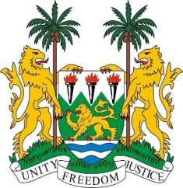
SIERRA LEONE
23rd Session of the UPR

AUSTRALIA

9 November 2015

Mr President,

Sierra Leone welcomes the delegation of Australia and thanks them for their presentation.

My delegation commends the human rights policies developed by the Australian government in recent years, including the National Human Rights Action Plan and the Indigenous Adjustment Strategy. We further note the National Framework for Protecting Australia’s Children which prioritises support for children of Aboriginal and Torres Strait Islander descent.

Sierra Leone notes that Australia has transformed itself into a multicultural, harmonious and ethnically diverse nation that it is today.

This notwithstanding my delegation is concerned by reports of forced repatriation of migrants and asylum seekers some of whom are in dire need of protection and of the situation in detention centres outside Australia.

Recommendations:

- Ratify ICPPED and ICRMW.
- Submit overdue reports to CERD, CESCR, CCPR and CEDAW.
- Implement further measures to close the gender pay gap.
- Increase its ODA from the current 0.33% to 0.7% of GDP

To conclude, Sierra Leone is pleased to notes that Australia has been a contributor to OHCHR programmes and wishes Australia success in this second cycle.

Thank you, Mr President.

